Reusable Light box
This utility allows you to display SharePoint list items as Light Box links and when clicked on it, it displays specified field values in a light box. In this example, list items “Title” is shown as links and “Description” field values of the item is displayed in the light box.
List items to display are determined by “CamlQuery” parameter in the spservices() function. In this example, all the list items are shown in descending order of the date modified. Html structure for the light box is built at the run time.
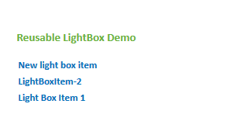
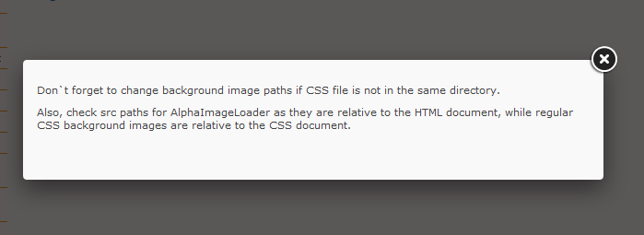

Steps to setup the light box
- Copy folder “LightBox” to the site where you would like to setup the lightbox.
- Open file “lightBoxScript.js”.
- Edit list_Name variable to link to the list you wanted.
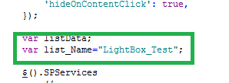
- Update “itemTitle” variable inside “bindResults” function as required. This variable determines which field value to display as links.
- Update “itemDescription” variable inside “bindResults” function as required. This variable determines which field value to display the lightbox body.
- Update “LightBox_UI.html” file as required. This file has the shell “divs” where the html generated at the run time is inserted. Modify the URLs to point to where the files are located now.
- Update “LightBoxStyle.css” file to modify look and feel of the UI and lightbox.
- This example can be found at this location

http://insidestage.rush.edu/Departments/Corporate/InformationServices/TeamSites/webteam/Pages/test.aspx

